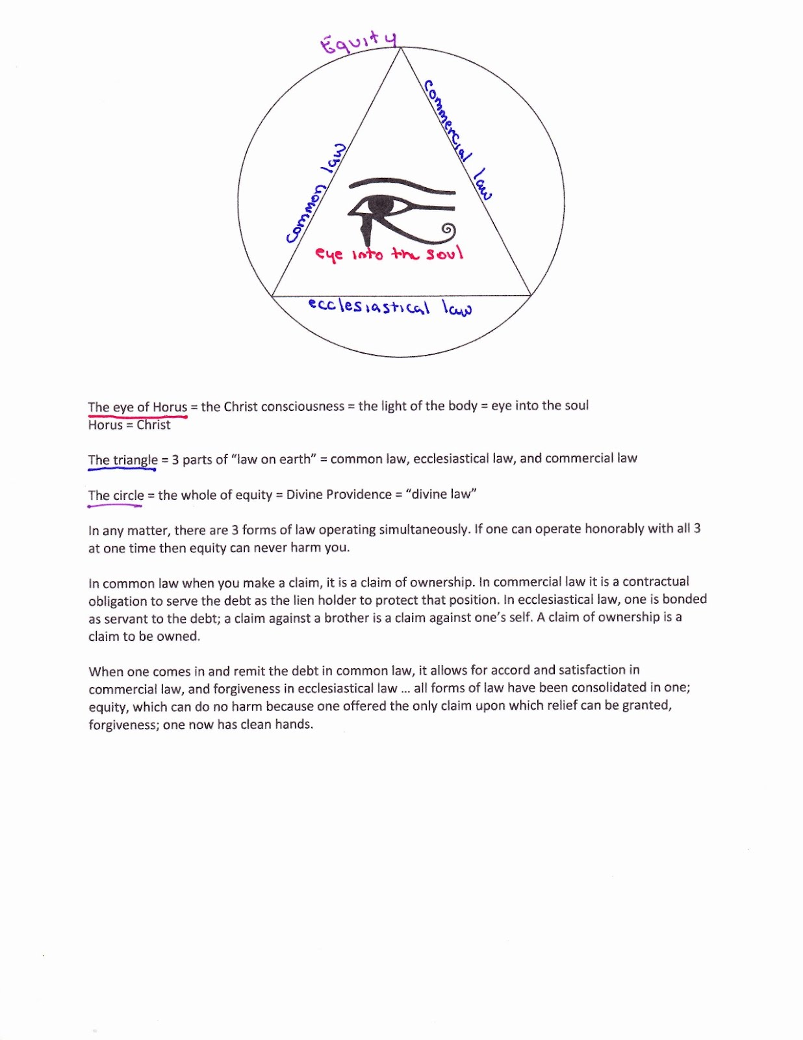
The eye of Horus the Christ consciousness the light of the body eye into the soul
The triangle 3 parts of on earth" common law, ecclesiastical law, and commercial law
The circle the whole of equity Divine Providence ”divine law"
In any matter, there are 3 forms of law operating simultaneously. If one can operate honorably with all 3 at one time then equity can never harm you.
In common law when you make a claim, it is a claim of ownership. In commercial law it is a contractual obligation to serve the debt as the lien holder to protect that position. In ecclesiastical law, one is bonded as servant to the debt; a claim against a brother is a claim against one’s self. A claim of ownership is a claim to be owned.
When one comes in and remit the debt in common law, it allows for accord and satisfaction in commercial law, and forgiveness in ecclesiastical law all forms of law have been consolidated in one; equity, which can do no harm because one offered the only claim upon which relief can be granted, forgiveness; one now has clean hands.

